**Experiment - 11**

**AIM-** To generate test cases for a program which gives the nature of roots of a quadratic equation of the form (ax^2+bx+c) using Boundary Value Analysis.

**ALGORITHM-**

1. Take as input the values of a, b and c. Since there are 3 variables, the number of test cases generated would be equal to 4n+1 where n is the number of variable. 13 test cases will be generated for this case.
2. Variable are given extreme and nominal values. When a variable is given an extreme value, other variables are given nominal values.

# CODE-

#include<iostream> using namespace std; void getOutput(int a, int b, int c){

int det = (b*b) - (4*a*c); if(a == 0){

cout<<"Not Quadratic";

} else if(det < 0){

cout<<"Imaginary Roots";

} else if(det == 0){

cout<<"Equal Roots";

} else {

cout<<"Real Roots";

}

} int main(){

int a, b, c; int as, ae, bs, be, cs, ce;

cout<<"Enter ranges of a, b, c"; cin>>as>>ae; cin>>bs>>be; cin>>cs>>ce;

float nomA = (as + ae)/2; float nomB = (bs + be)/2; float nomC = (cs + ce)/2; cout<<as<<" "<<nomB<<" "<<nomC<<" "; getOutput(as, nomB, nomC); cout<<"\n"; cout<<(as + 1)<<" "<<nomB<<" "<<nomC<<" "; getOutput(as+1, nomB, nomC); cout<<"\n";

cout<<ae<<" "<<nomB<<" "<<nomC<<" "; getOutput(ae, nomB, nomC); cout<<"\n"; cout<<(ae - 1)<<" "<<nomB<<" "<<nomC<<" "; getOutput(ae - 1, nomB, nomC); cout<<"\n";

cout<<nomA<<" "<<bs<<" "<<nomC<<" "; getOutput(nomA, bs, nomC); cout<<"\n"; cout<<nomA<<" "<<(bs + 1)<<" "<<nomC<<" "; getOutput(nomA, bs + 1, nomC); cout<<"\n";

cout<<nomA<<" "<<be<<" "<<nomC<<" "; getOutput(nomA, be, nomC); cout<<"\n"; cout<<nomA<<" "<<(be - 1)<<" "<<nomC<<" "; getOutput(nomA, be - 1, nomC); cout<<"\n";

cout<<nomA<<" "<<nomB<<" "<<cs<<" "; getOutput(nomA, nomB, cs); cout<<"\n"; cout<<nomA<<" "<<nomB<<" "<<(cs + 1)<<" "; getOutput(nomA, nomB, cs + 1); cout<<"\n";

cout<<nomA<<" "<<nomB<<" "<<ce<<" "; getOutput(nomA, nomB, ce); cout<<"\n"; cout<<nomA<<" "<<nomB<<" "<<(ce - 1)<<" "; getOutput(nomA, nomB, ce - 1); cout<<"\n";

cout<<nomA<<" "<<nomB<<" "<<nomC<<" "; getOutput(nomA, nomB, nomC); cout<<"\n";

return 0;

}

**OUTPUT:**

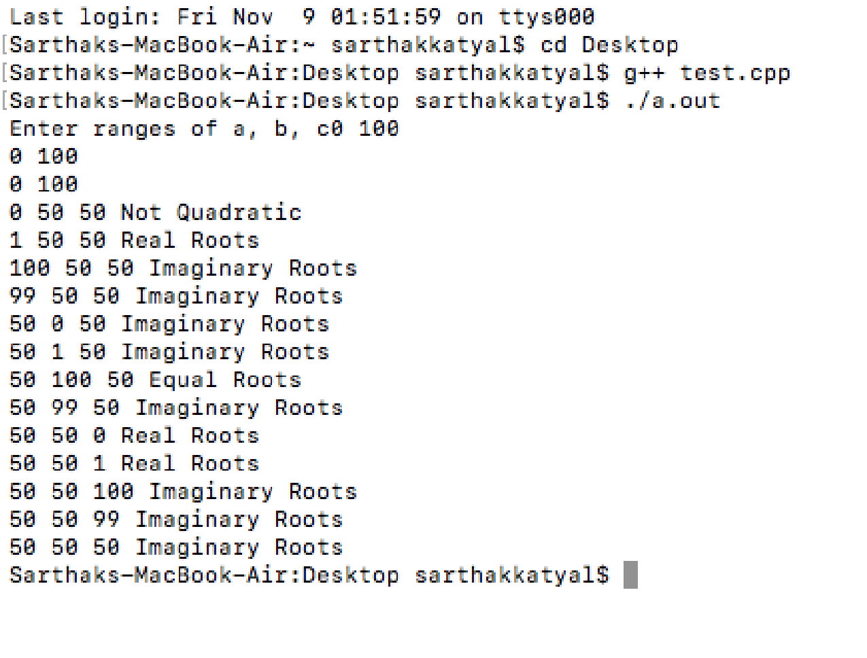

**LEARNING :** Boundary value analysis is used to generate 4n+1 test cases for n variables, where when an extreme value is given to a variable, the other variables take up the nominal values.